CSE446/598 Assignment1
Readme
Shihuan Shao
- Download the zipped package “Shihuan Shao final submission”.
In the folder of mongodb (suppose the path is D:\Program Files\mongodb), enter the bin folder. Copy the dump folder which contains a folder called sshao1 into the bin folder. In sshao1, there are four bson/json files, which are necessary to restore the database. You also need to create a folder called data in the folder mongodb.
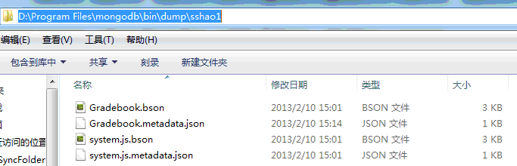

Another way to restore the db in case the mongorestore does not work: Create a folder called data in the folder mongodb and copy the files in the alternative folder into the data folder.
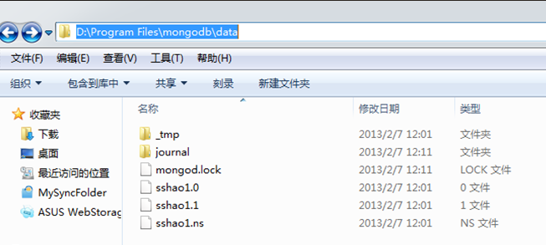

- Run cmd and enter the bin folder of mongodb
D:\Program Files\mongodb\bin.
Then type mongod –dbpath “D:\Program Files\mongodb\data”
The following figure means you started the mongodb successfully.

3. Keep the mongodb running. Now run another cmd, and enter the bin folder of mongodb.
Restore the database:
mongorestore --db sshao1 "D:\Program Files\mongodb\bin\dump\sshao1"
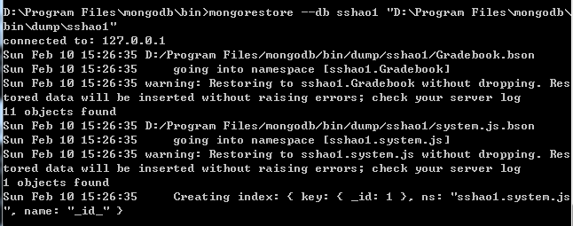

Now the database is restored. Then type mongo to start the mongo shell, or you can directly click the mongo.exe. You will see:
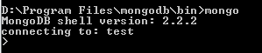

Then switch to database sshao1 using instruction use sshao1
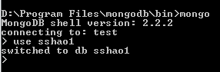

- Now you can do whatever you want.
(1) If you want to list all undergrad students and their grades, use the instruction
db.eval("gradeFunction('Undergrad')")
Undergrad (Note: “U” is uppercase) is student category parameter. By using this instruction, the grading script will be automatically called to calculate the student’s total score and letter grade.
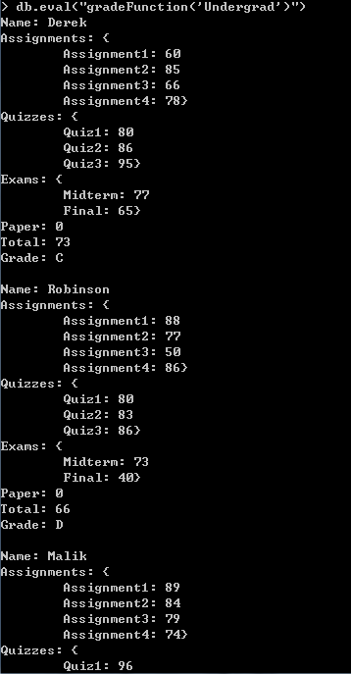
Grades of one of the students

(2) If you want to list all grad students and their grades, use the instruction
db.eval("gradeFunction('Grad')") Note: “G” in “Grad” is also uppercase.
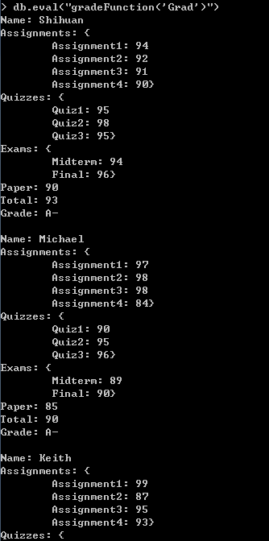

(3) To query students called “Derek”, type
db.Gradebook.find({"Name" : "Derek"}).forEach(printjson)
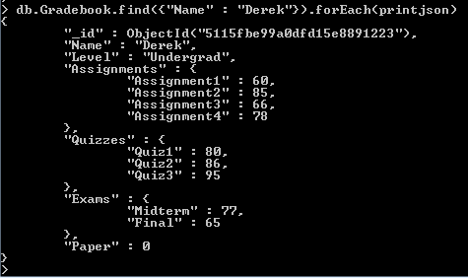

(4) To add a new document for student Chris and his grades, you need to first create a document:
Chris = {Name : "Chris", Level : "Undergrad", Assignments : {Assignment1 : 60, Assignment2 : 85, Assignment3 : 66, Assignment4 : 78}, Quizzes : {Quiz1 : 80, Quiz2 : 86, Quiz3 : 95 }, Exams : {Midterm : 77, Final : 65}, Paper : 0};
Note: The instruction above should be typed in one line.
Then db.Gradebook.insert(Chris);
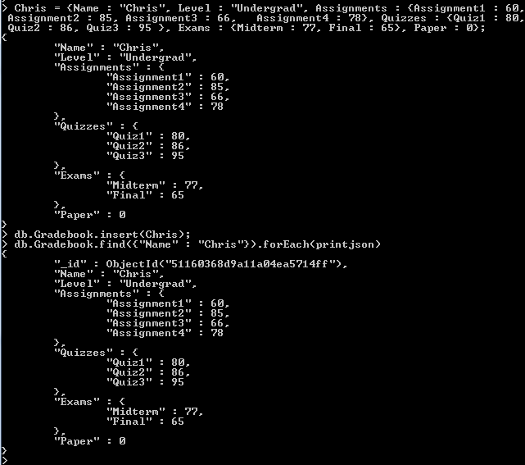

(5) To update Chris’s grade of Assignment1:
db.Gradebook.update({"Name":"Chris"},{"$set":{"Assignments.Assignment1" : 100 }})
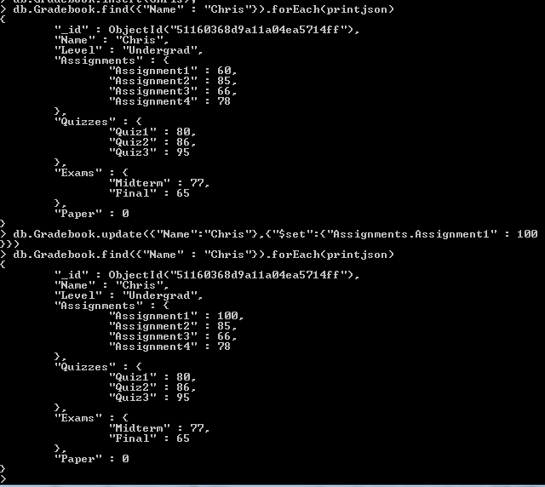

Because of the structual similiarity, the update of quiz scores and exam scores are the same.

(6) To update Chris’s grade of paper:
db.Gradebook.update({"Name":"Chris"}, {"$set":{"Paper" : 50}})
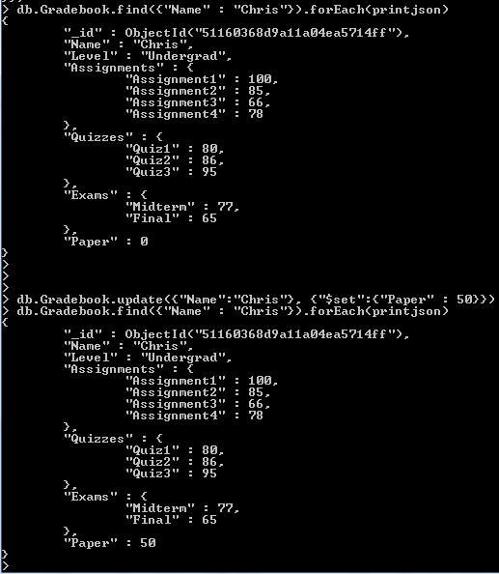

(7) To remove the document of Chris:
db.Gradebook.remove({"Name" : "Chris"})
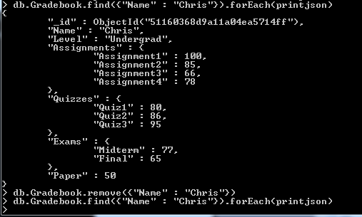
Nothing here

(8) To list all the documents in the collection sshao1,
db.Gradebook.find().forEach(printjson)
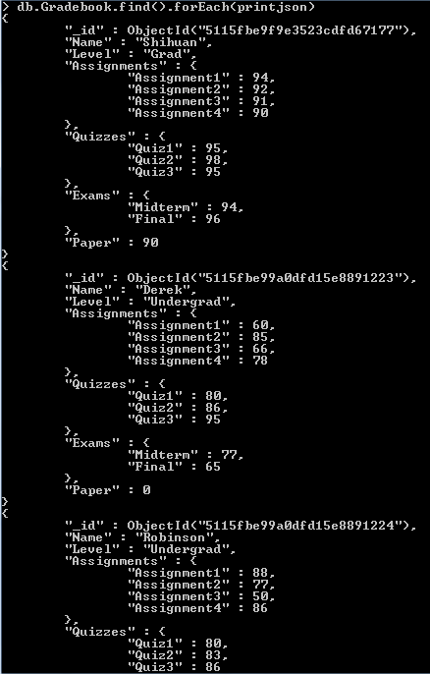

-End-

